Implement 3 and 4 Programs using TestNG Concepts and write it using @Test annotation.

Implement @DataProvider concept to read data from test cases

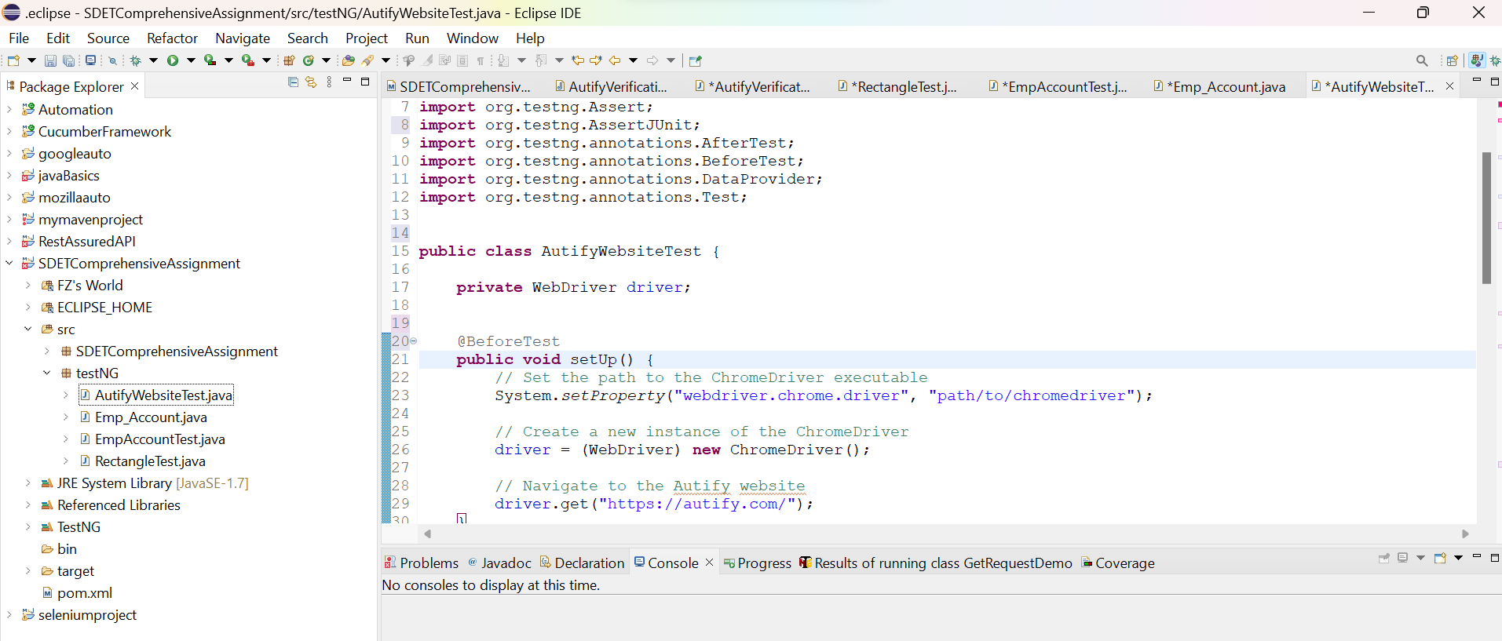

**import** org.openqa.selenium.By;

**import** org.openqa.selenium.WebDriver;

**import** org.openqa.selenium.WebElement;

**import** org.openqa.selenium.chrome.ChromeDriver;

**import** org.testng.Assert;

**import** org.testng.AssertJUnit;

**import** org.testng.annotations.AfterTest;

**import** org.testng.annotations.BeforeTest;

**import** org.testng.annotations.DataProvider;

**import** org.testng.annotations.Test;

**public** **class** AutifyWebsiteTest {

**private** WebDriver driver;

@BeforeTest

**public** **void** setUp() {

// Set the path to the ChromeDriver executable

System.*setProperty*("webdriver.chrome.driver", "path/to/chromedriver");

// Create a new instance of the ChromeDriver

driver = (WebDriver) **new** ChromeDriver();

// Navigate to the Autify website

driver.get("https://autify.com/");

}

@Test(dataProvider = "linksData")

**public** **void** testLinkPresence(String linkText) {

WebElement link = driver.findElement(By.*xpath*("//a[text()='" + linkText + "']"));

AssertJUnit.*assertTrue*(link.isDisplayed());

}

@Test(dataProvider = "buttonsData")

**public** **void** testButtonEnabled(String buttonText) {

WebElement button = driver.findElement(By.*xpath*("//button[text()='" + buttonText + "']"));

AssertJUnit.*assertTrue*(button.isEnabled());

}

@DataProvider(name = "linksData")

**public** Object[][] linksData() {

**return** **new** Object[][] {

{"Why Autify"},

{"Pricing"},

{"Webinars"},

{"Resources"}

};

}

@DataProvider(name = "buttonsData")

**public** Object[][] buttonsData() {

**return** **new** Object[][] {

{"Start Free Trial"},

{"Sign In"}

};

}

@AfterTest

**public** **void** tearDown() {

// Close the browser

driver.quit();

}

}

Implement 4 Programs using TestNG Concepts and write it using @Test annotation.

Implement @DataProvider concept to read data from test cases

Code:  
  
import org.openqa.selenium.By;

import org.openqa.selenium.WebDriver;

import org.openqa.selenium.WebElement;

import org.openqa.selenium.chrome.ChromeDriver;

import org.testng.Assert;

import org.testng.annotations.AfterTest;

import org.testng.annotations.BeforeTest;

import org.testng.annotations.DataProvider;

import org.testng.annotations.Test;

public class AutifyLinksVerificationTest {

private WebDriver driver;

@BeforeTest

public void setUp() {

// Set the path to the ChromeDriver executable

System.setProperty("webdriver.chrome.driver", "path/to/chromedriver");

// Create a new instance of the ChromeDriver

driver = new ChromeDriver();

// Navigate to the Autify website

driver.get("https://autify.com/");

}

@Test(dataProvider = "linksData")

public void testLinkTitle(String linkText, String expectedTitle) {

// Click on the link

WebElement link = driver.findElement(By.xpath("//a[text()='" + linkText + "']"));

link.click();

// Verify the title of the page

String actualTitle = driver.getTitle();

Assert.assertTrue(actualTitle.contains(expectedTitle), "Title verification failed for link: " + linkText);

// Navigate back to the homepage for the next verification

driver.navigate().back();

}

@DataProvider(name = "linksData")

public Object[][] linksData() {

return new Object[][] {

{"Why Autify", "Why Autify"},

{"Pricing", "Pricing"},

{"Webinars", "Webinars"},

{"Resources", "Resources"}

};

}

@AfterTest

public void tearDown() {

// Close the browser

driver.quit();

}

}